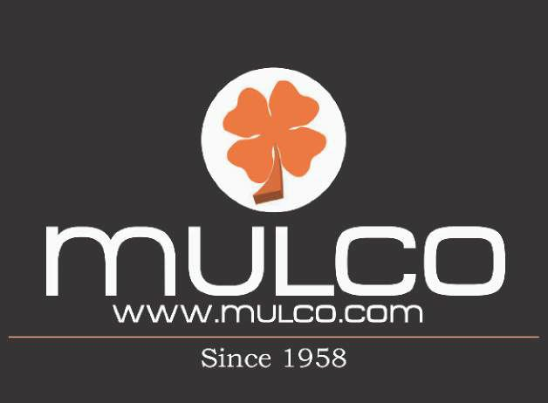

M u l c o S t o r e C o n c e p t

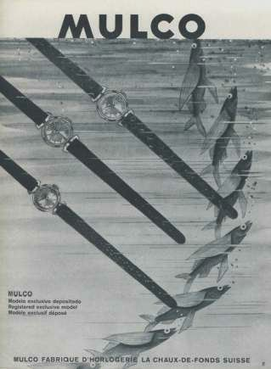
Our History

Since its creation in 1958 by Mr. Muller (Muller and Co.), MULCO quickly became a prestigious brand that stood head to head with other competitive Swiss watches.
With its suggestive designs and impeccable quality, this exclusive brand superseded the expectations of the demanding European, American and South American markets.
MULCO maintained its place in the market until it was bought by one of its competitors
in 1973. For three decades the brand remained a sleeping giant only to be reawakened in 2006 by a group of visionary entrepreneurs.

Never forgotten by its followers for its impressive product lines and distinguished quality, MULCO stood the test of time, mesmerizing customers once more with the brand’s new look. MULCO Watches, Inc. gathered a dynamic group of fashion designers, and watch makers creating a fashionable and stunning collection. Most importantly, the new MULCO inherited the classic seal of quality that people have come to expect from the brand.
MULCO is now committed to continue its legacy by constantly updating models and improving the brand, altogether creating the best timepiece you can wear.

Timeline

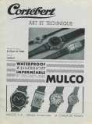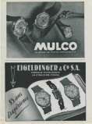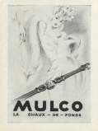

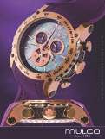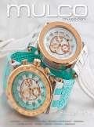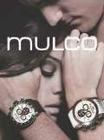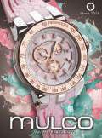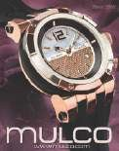

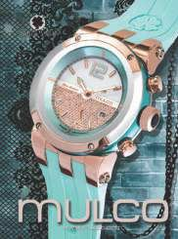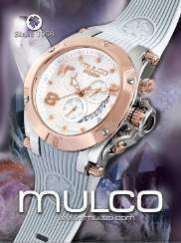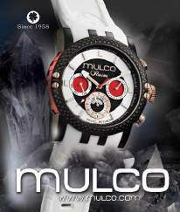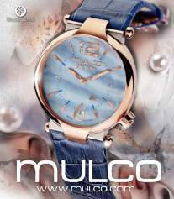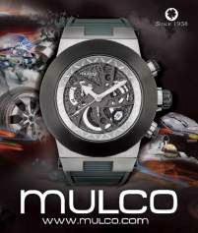

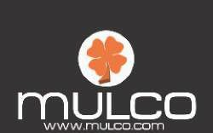

Around the world

MULCO is present in 32+ countries and continues to extend its reach by making strong alliances with international markets. In these countries MULCO has established itself through reputable ne jewelry stores, department stores and duty-free shops.

The collections are displayed in over 1,000 locations worldwide truly positioning MULCO as a global company. Our participation in prestigious international tradeshows such as: Baselworld in Basel, Switzerland, JCK show in Las Vegas, USA, Iberjoya in Madrid, Spain, enables us to encounter new business opportunities and alliances.
Some of the most prestigious alliances worldwide are:

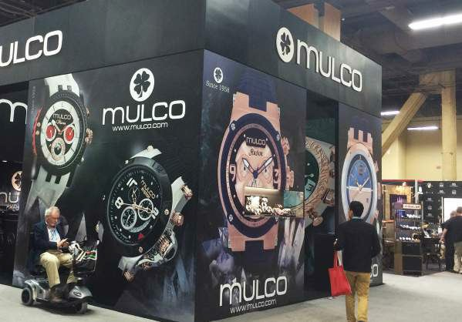
Tourneau
Bloomingdales
Macys
Duty free
Falabela
Jewelers Chain
Cruises

Global Presence

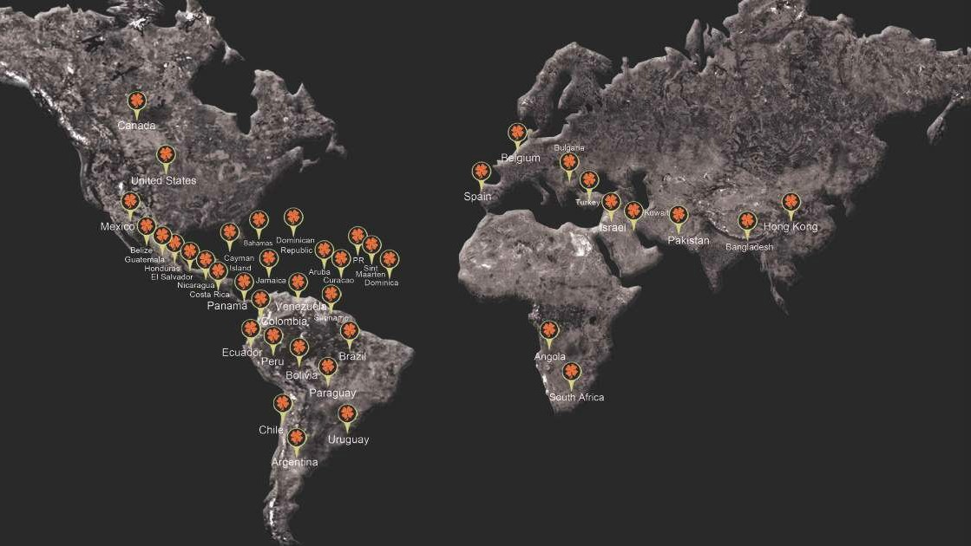

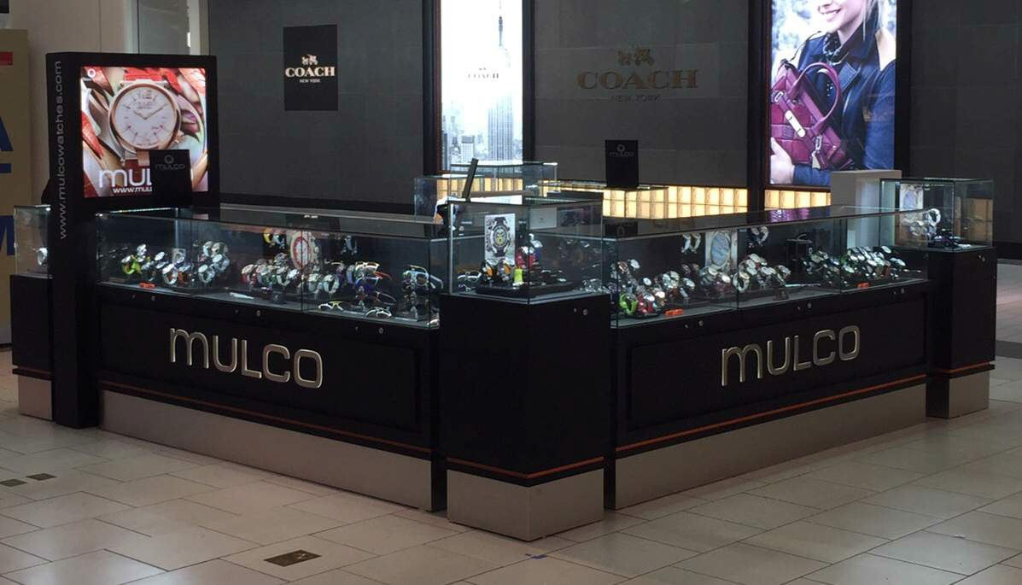

Mulco Kiosk - Dadeland Mall Miami, Florida, U.S.A.

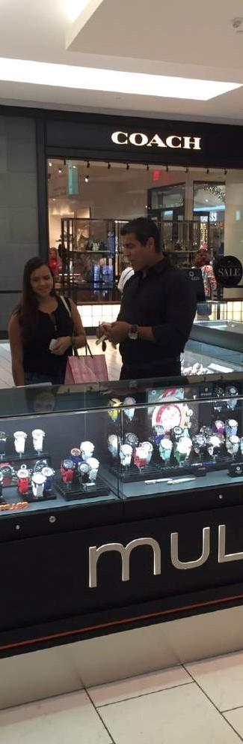
Mulco Feeling
Where time and space become one...

We create a unique concept where the consumer can freely experience the full scope and
flavor of the mulco universe. By offering an interactive space with the unmistakably
‘’Mulco Vibe’’, we want to create an emotional connection that will entice the consumer to
belong and identify with the brand by buying any Mulco item.Additionally,
it is the perfect platform to launch and test new collections and products prior to any other
points of sale as it will be the only store where will be able to display over 350 SKU’s,
as well as 60+ sunglasses and 15+ pens.Each Mulco retail space (store or kiosk)
will also offer incentives to tempt the consumer to buy one or more articles.

After conducting a comprehensive analysis on consumer behavior in today's market environment,
we came to the conclusion that the future lies into opening exclusive Mulco retail spaces
(Mulco stores and Mulco Kiosks) with a unique Mulco atmosphere.

Those Mulco retail centers will follow the same price and marketing policies as an online store
with the added value of being a physical place where the client will be able to touch and
feel and try each product.

We will also have an onsite technical support and our sales experts that will provide excellent
product knowledge and reinforce the Brand identity.

It is important to note that each Mulco store will be supported with merchandising key items such
as: images, displays, advertising campaigns, sales incentive strategies, special event planning
and social media content.

In addition. it will have our graphic department direct assistance for the construction of the
MULCO space.

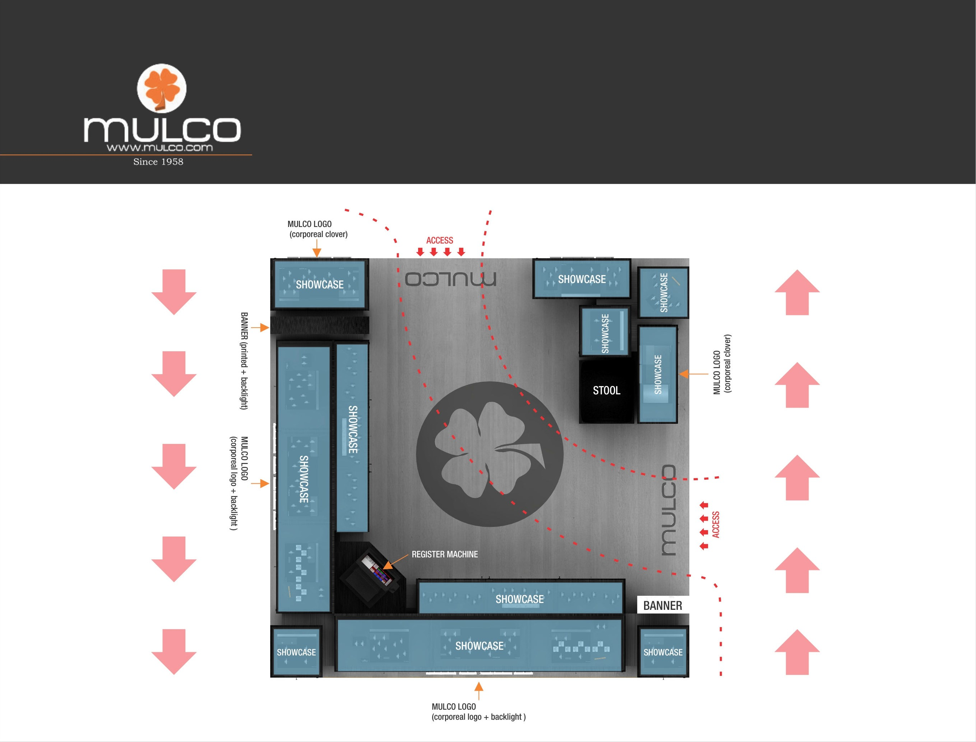

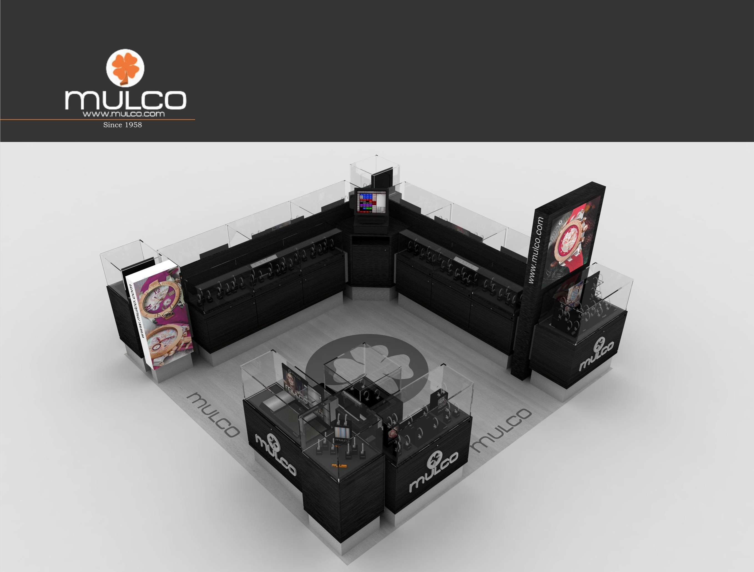

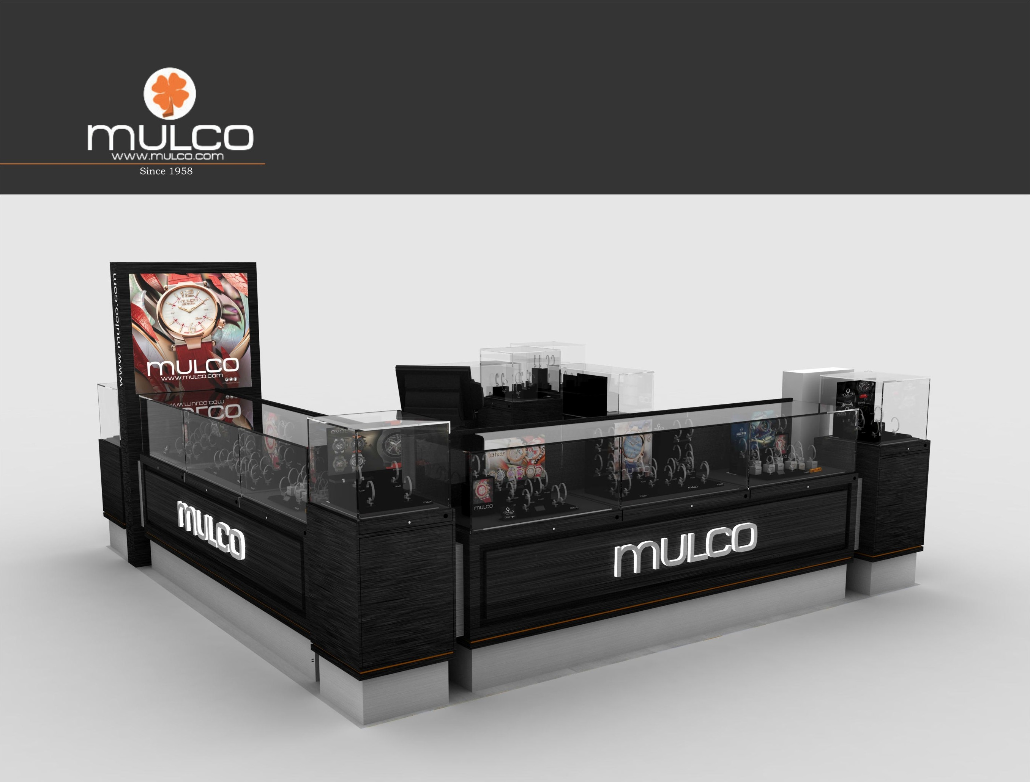

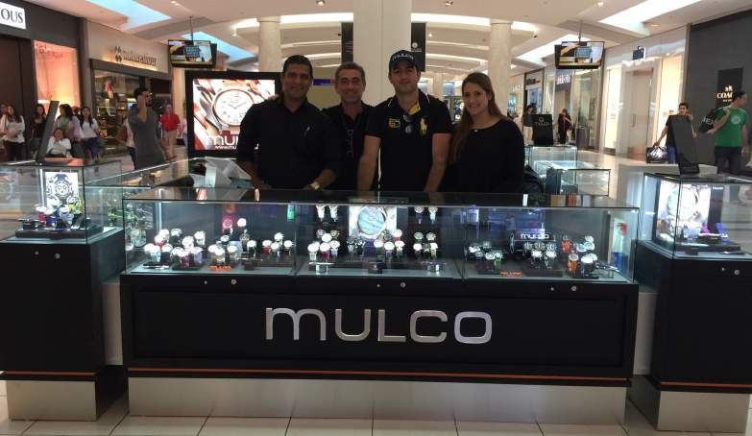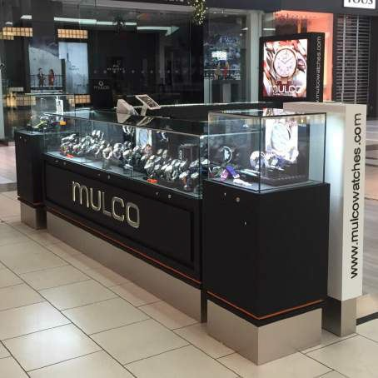
Mulco Kiosk - Dadeland Mall
Miami, Florida, U.S.A.

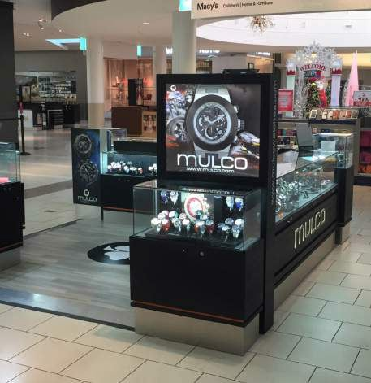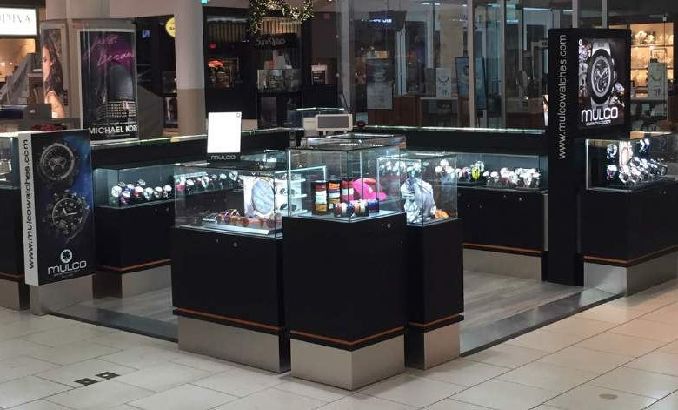

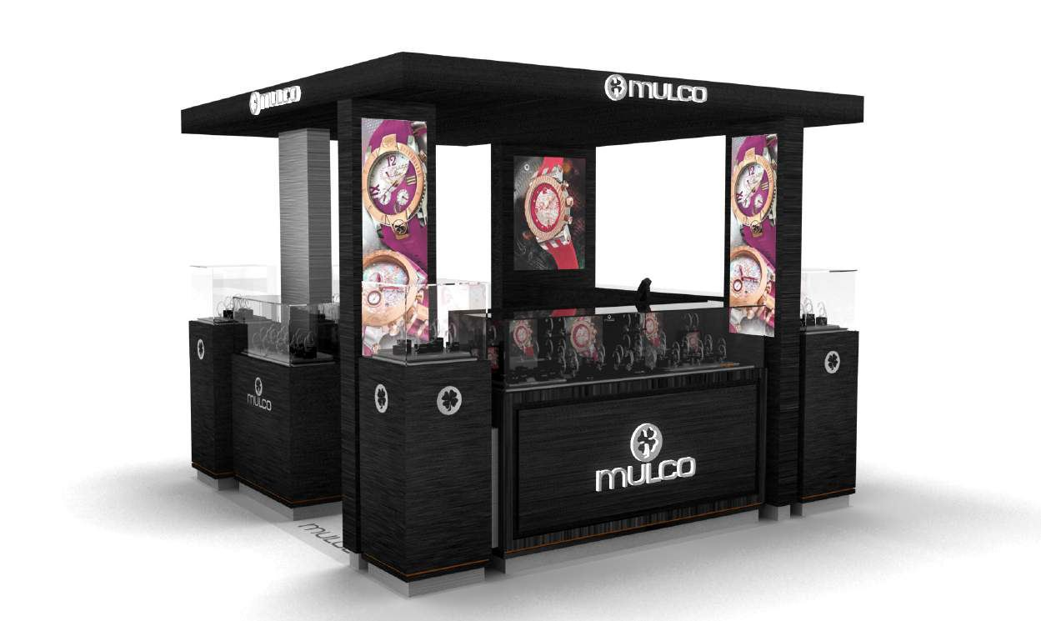

Mulco Kiosk - Roofed

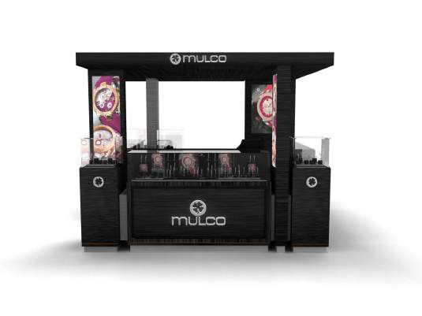
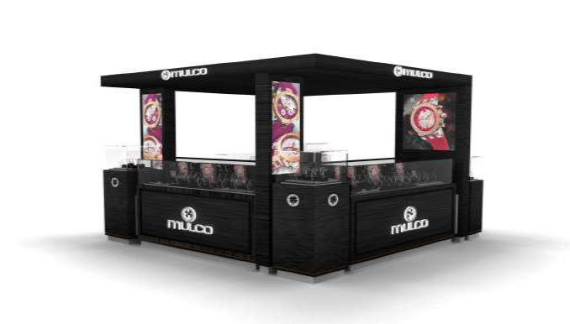
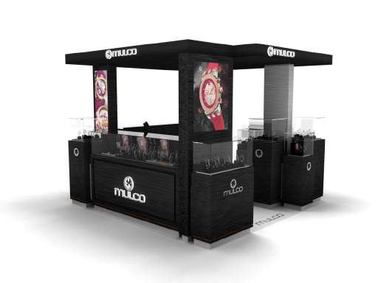
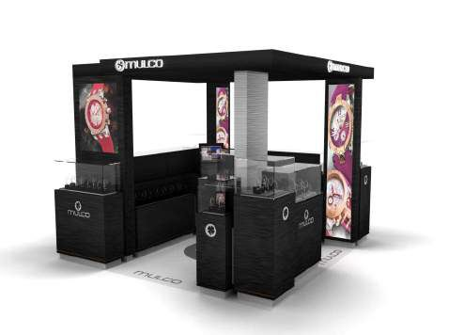

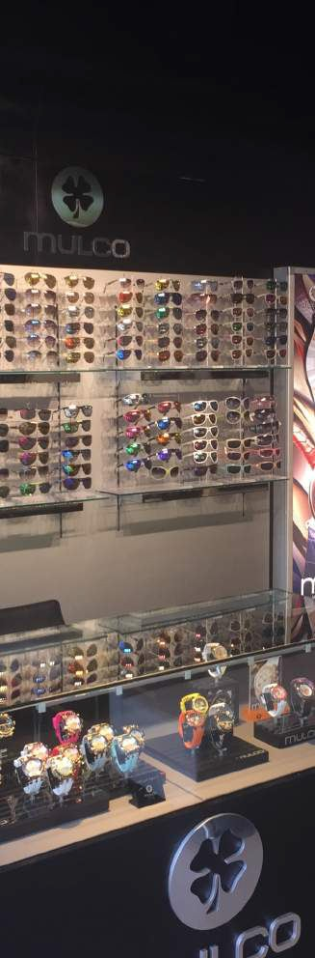

Mulco Custom Store
Mulco Store has the same concept as the Mulco Kiosk with all the best attributes of Mulco
products and intends to recreate the Mulco feeling in a larger space. The proposal on this
concept should be as detailed as the Mulco kiosk in order to make it a protable store.

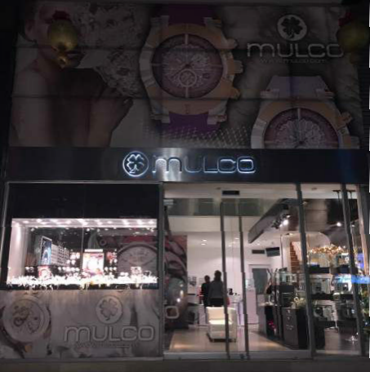
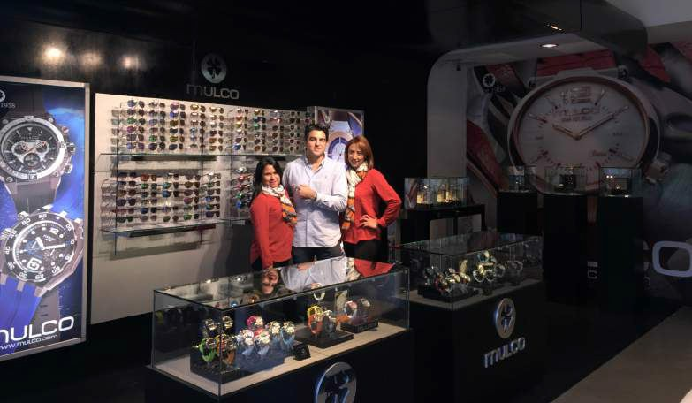
Mulco Custom Store Bogotá, Colombia.

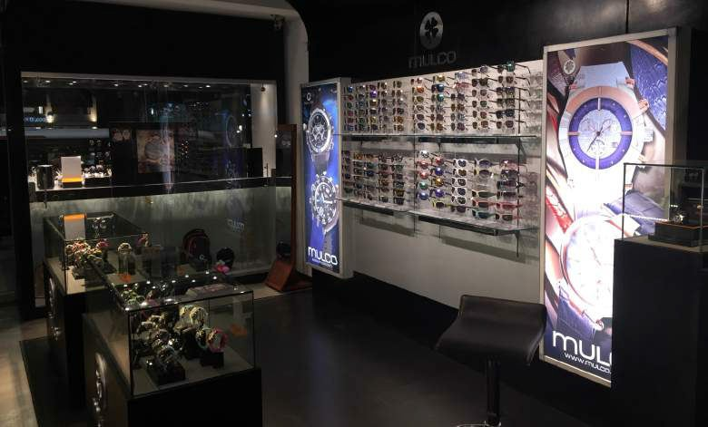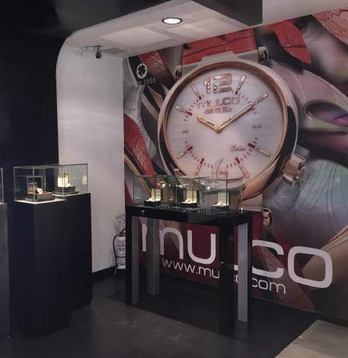

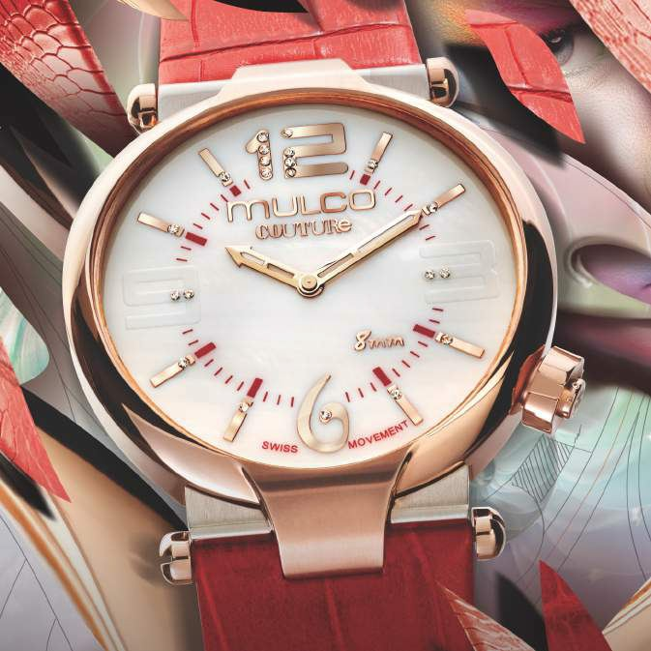

C O L L E C T I O N S

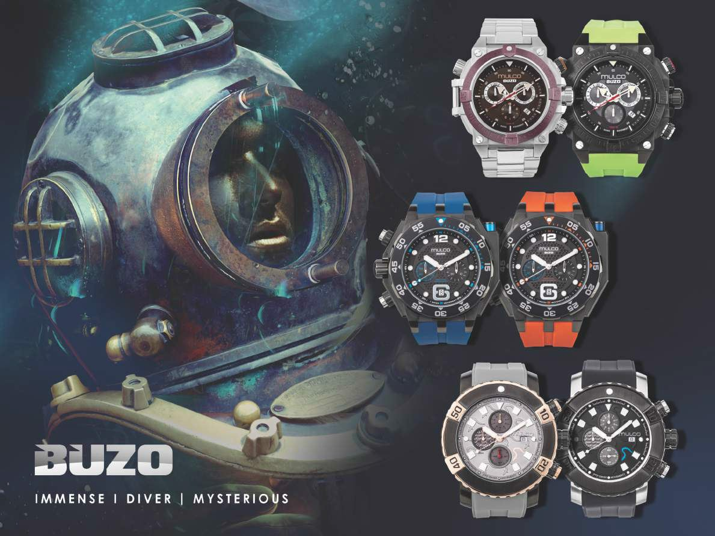

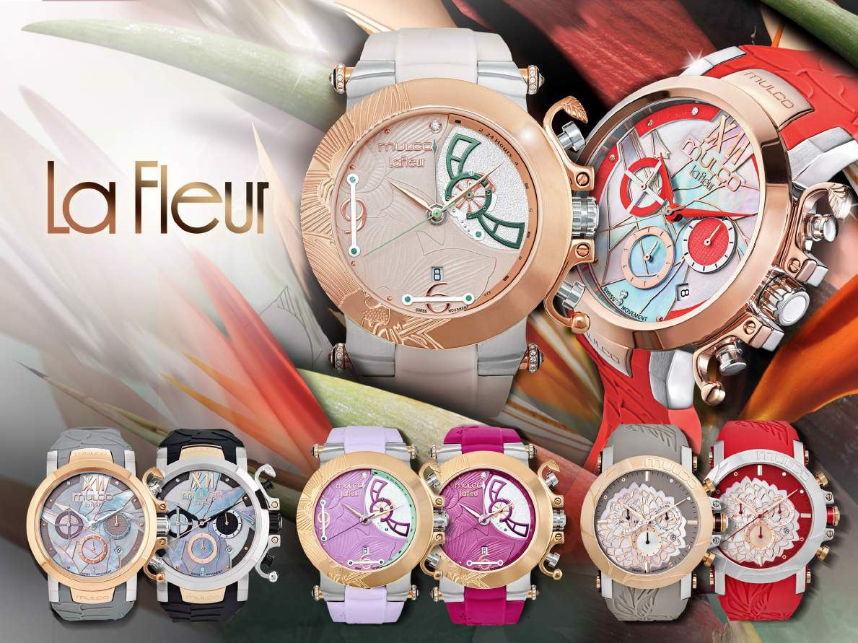

ELEGANT NATURAL COLORFUL

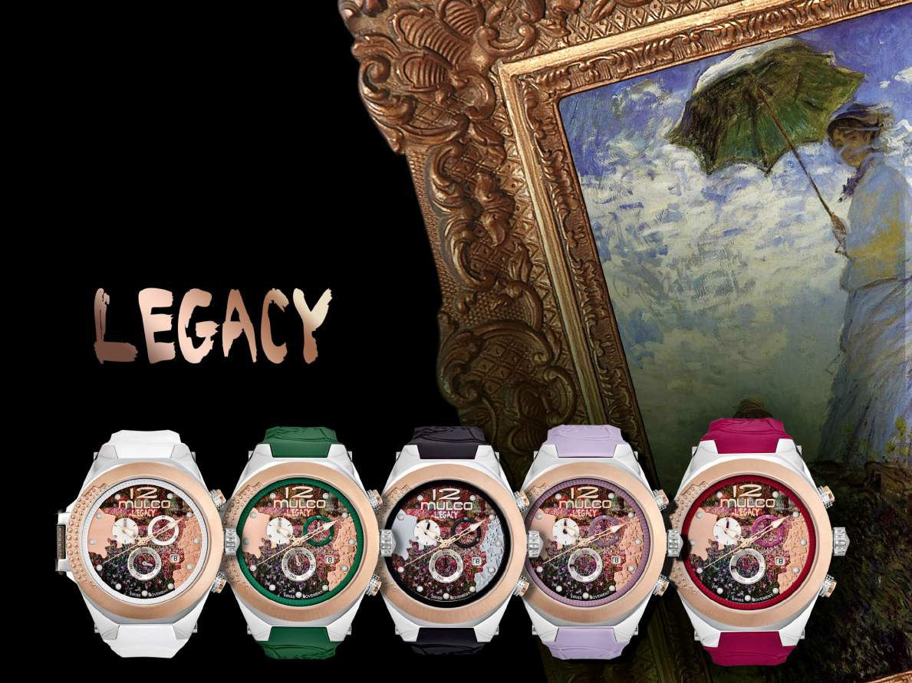

MOTIVATIONAL CREATIVE ABSTRACT

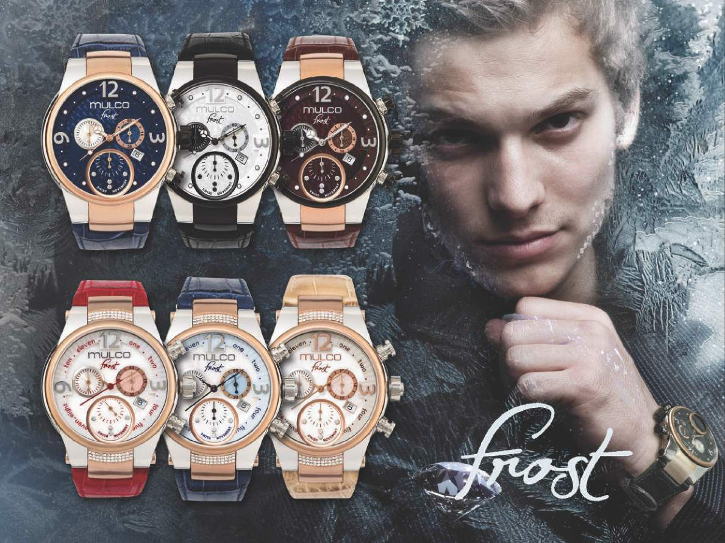

Frost Collection: strong, gallant and powerful

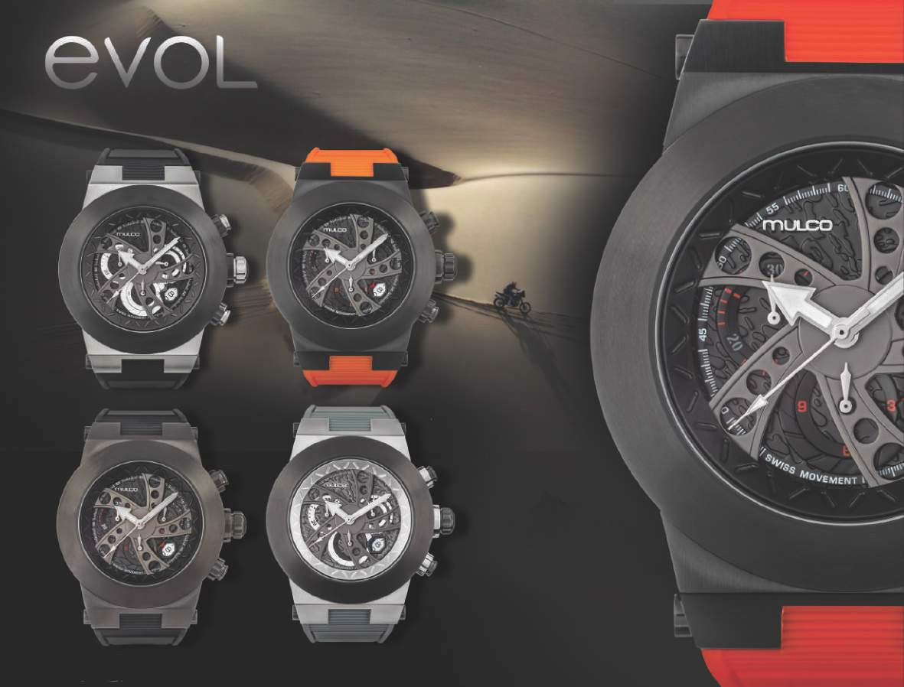

Evol Collection: adventurous, aggressive and powerful

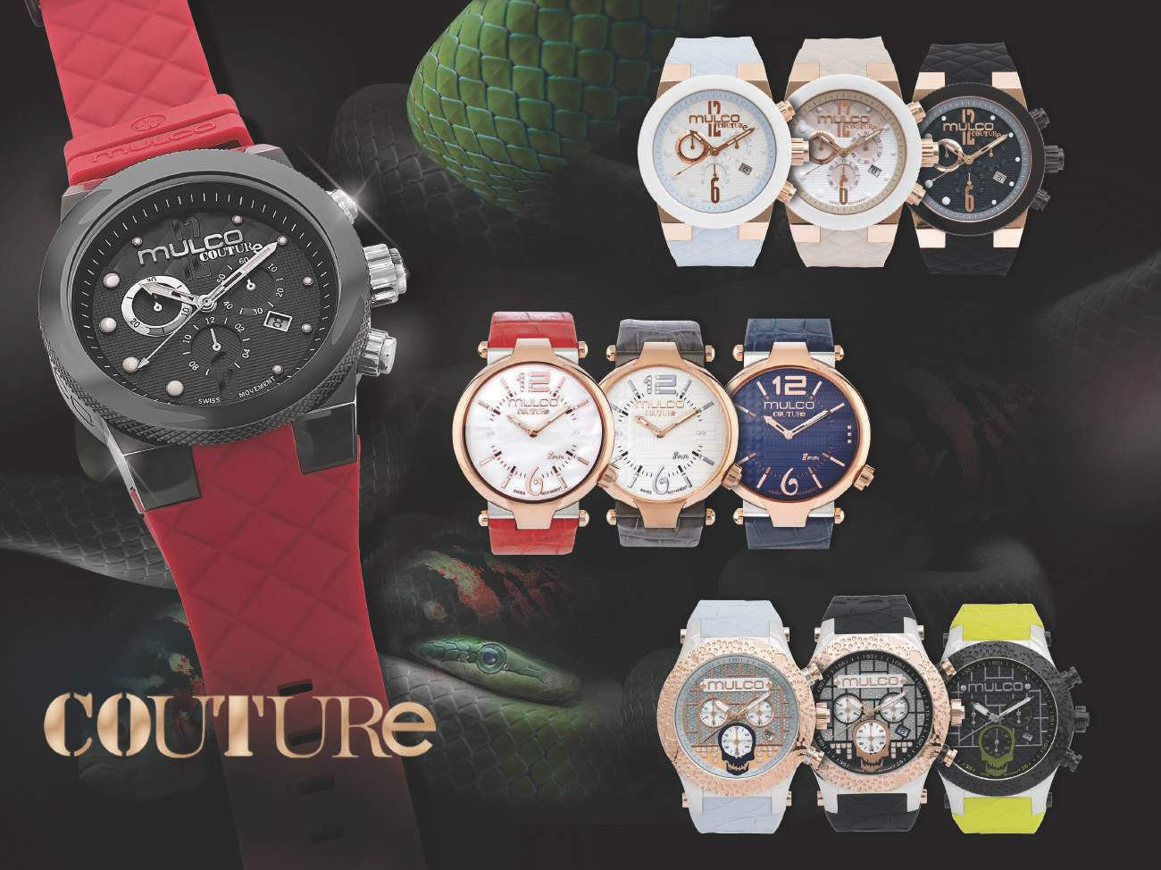

Couture Collection: vintage and exquisite

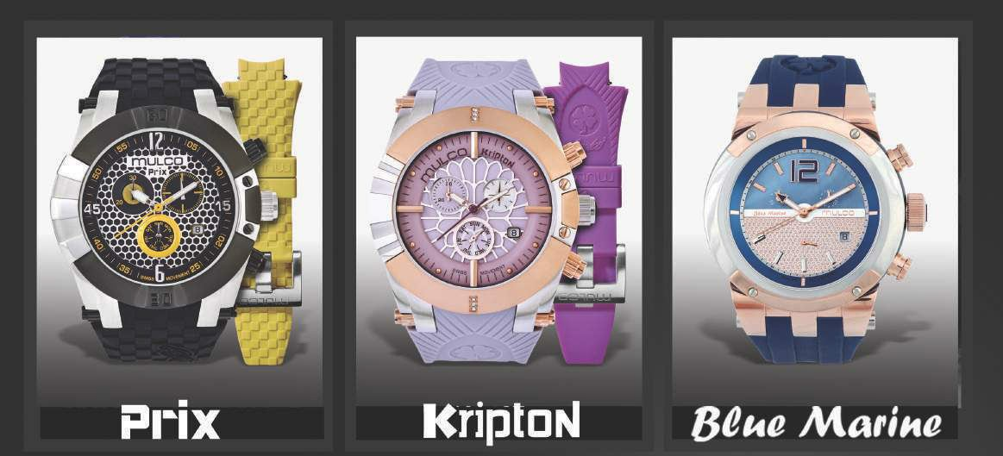

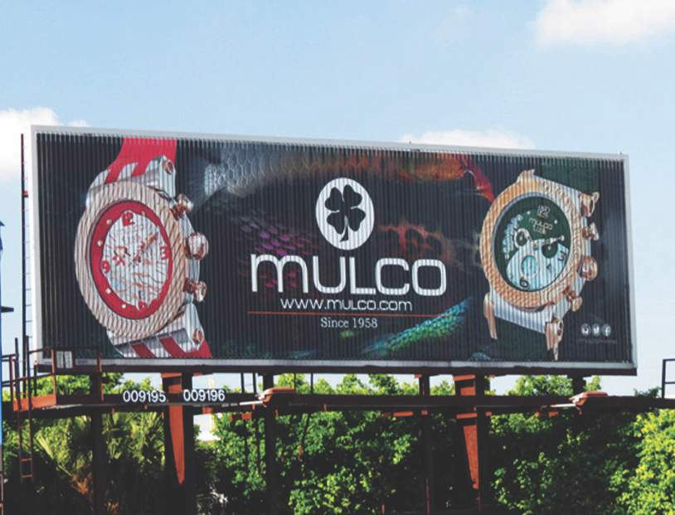

A D V E R T I S I N G

Advertising Initiatives
MULCO’s strong presence in different advertising fronts is the key element in our increased sales and success.
Therefore, the advertising campaign is changed every 4 months, and is massively distributed among all the points of sales worldwide to show an unanimous image and presence.

Each campaign is launched to increase brand awareness through various advertising channels such as:

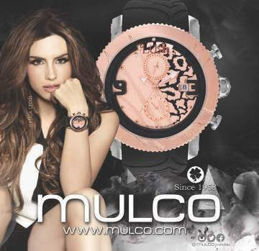

Magazines
Billboards
Social Media
Tradeshows
Events Sponsorship
Visual Merchandising
TV Advertising
Celebrity Endorsement
Mulco Ambassadors
(Chica HTV Latin American market)

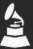

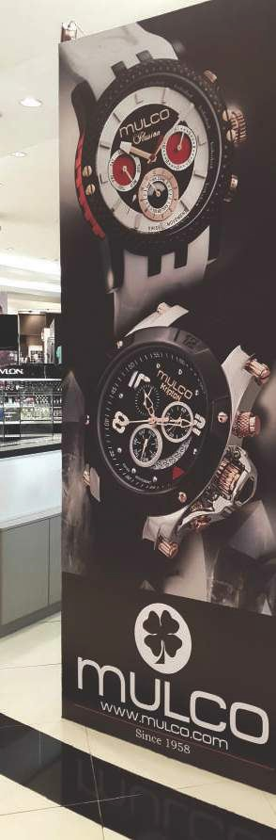

Billboards

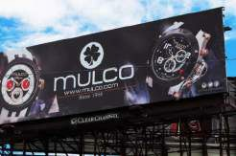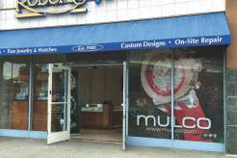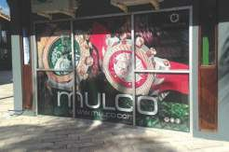
T T

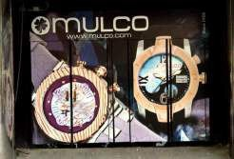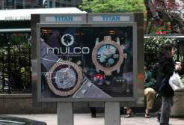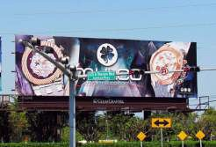

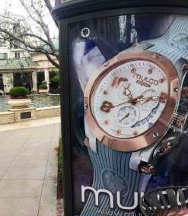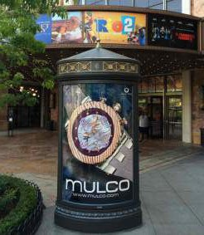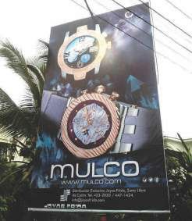
T T

Points of Sale

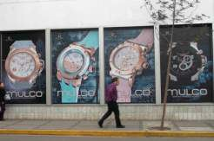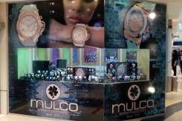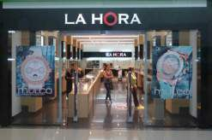

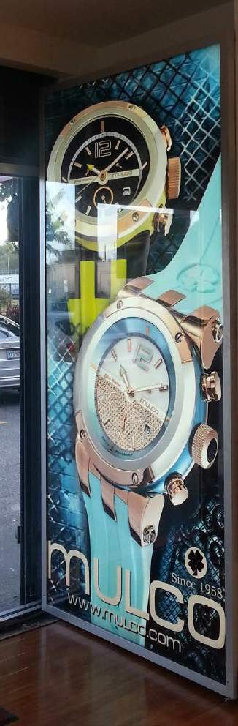
Ripley Miraores, Perú
Eye Protection, Miami, FL

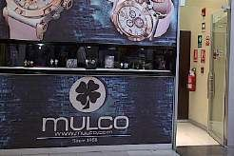

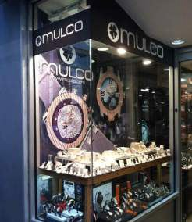
The Time, Lima, Perú
AlDejeni shop in Kuwait

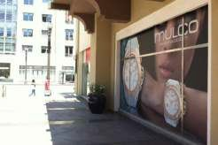

Watch Hub ,Pasadena, California

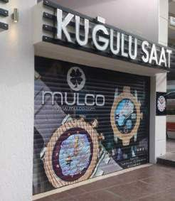
T
Duty Free

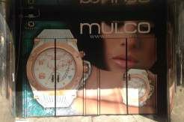

Christi Sothers, New York City

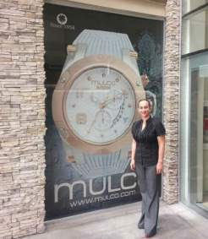
D'Oro Jewelers, California

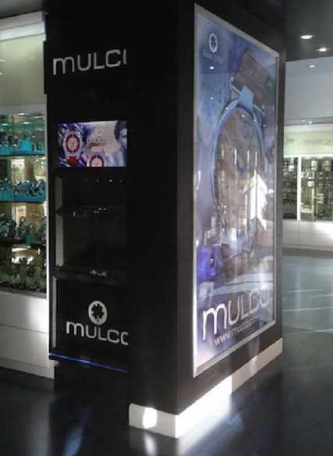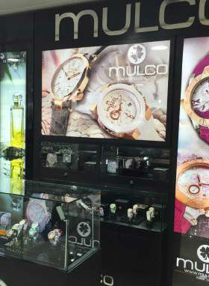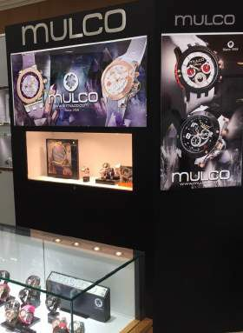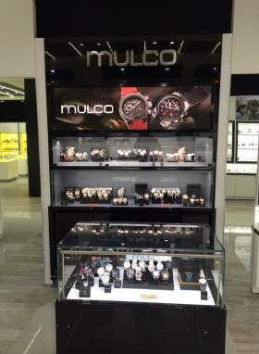

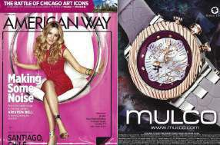
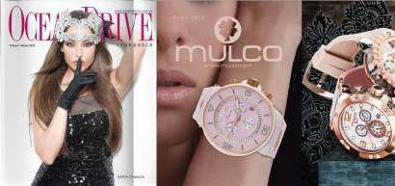

Magazine Advertising

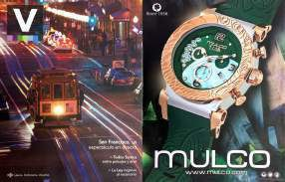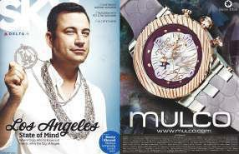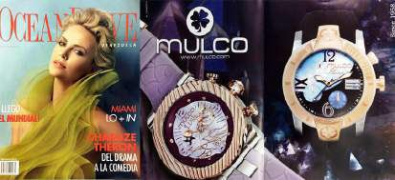

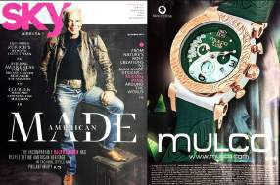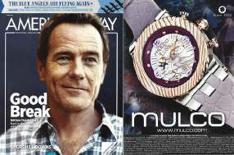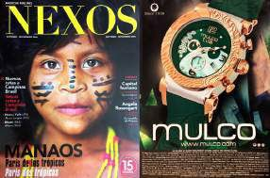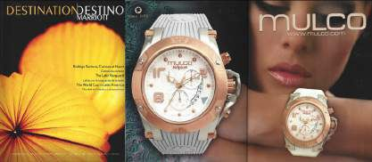

Social Media Initiative
Social media is changing the way we communicate with our customers. Having a versatile and dynamic collection with new models being launched several times a year, it is very important to communicate and quickly share those novelties and trends to our followers and fan base. In addition, it allows us to share at once with the world any new product launch, event, marketing initiative or latest news related to the growth and development of Mulco Watches worldwide.




For all those reasons, social media has become one of the most important aspects of our business. We count with a group of creative designers and social media experts that are able to communicate our ideas, designs and who can put into graphics the personality of our company: fashion forward, innovative and ever evolving.

We use all major social media channels and are strongly present in:

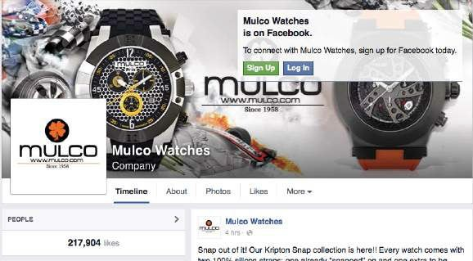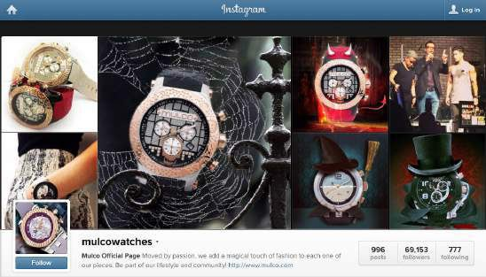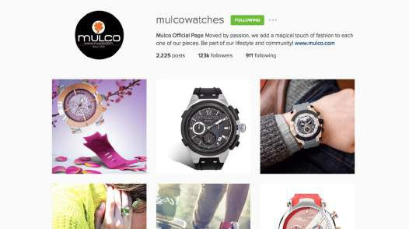

Marketing Strategy
Highlights for 2015

2015 Baselworld Show in Switzerland

2015 JCK Show in Las Vegas, United States

Billboard Campaigns Worldwide

Bloomingdale’s Trunk Shows

Macy’s Launch

Mulco Launch Events Worldwide

Mulco Ambassadors

Social Media Massive Campaigns

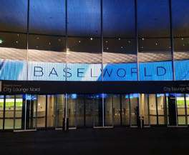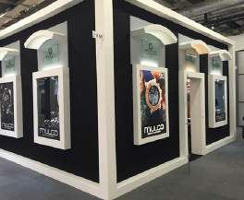
Miami Fashion Week - 2015

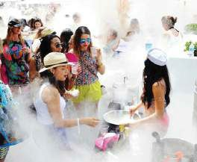
JCK Show, Las Vegas - 2015

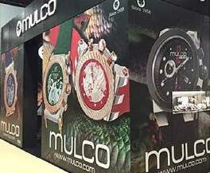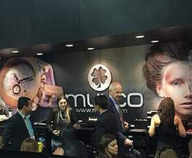
BaselWorld, Suiza - 2015

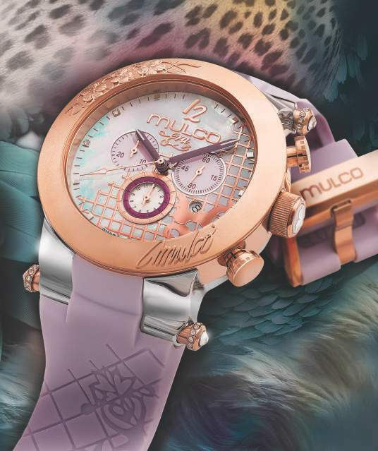
Competitive Advantages
Swiss Made Movement
Global Presence
Fashion forward and unique watch designs
Multiple Brand Ambassadors in different countries
Wide variety of watches for every taste, from conservative to trendy
Consistency in campaign image throughout all countries
Partnership with local distributors for national advertising in each
country
Launch of new models every quarter to keep the brand evolving and
in line with fashion trends
Strong presence in prestigious trade shows such as JCK show in
Las Vegas, USA and Basel World show in Switzerland

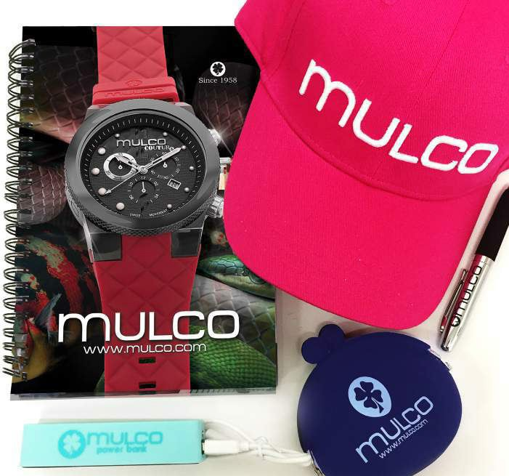

M E R C H A N D I S I N G

Display
In order to maintain consistent branding and optimal sales, we work closely with all our points of sale to have the merchandise displayed uniformly according to our corporative guidelines.

The watch display should tell a story by displaying each time pieces from the same collection together and ow to the next. There are four display sizes available: small for counters, medium for showcases and large and Large #2 for windows.

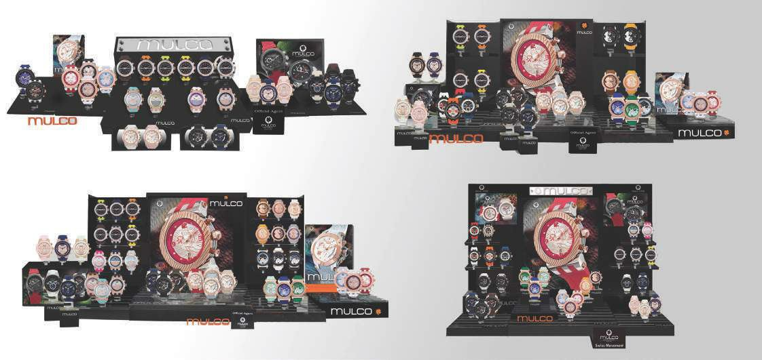
Small Display
Medium Display
Large Display
Large Display # 2

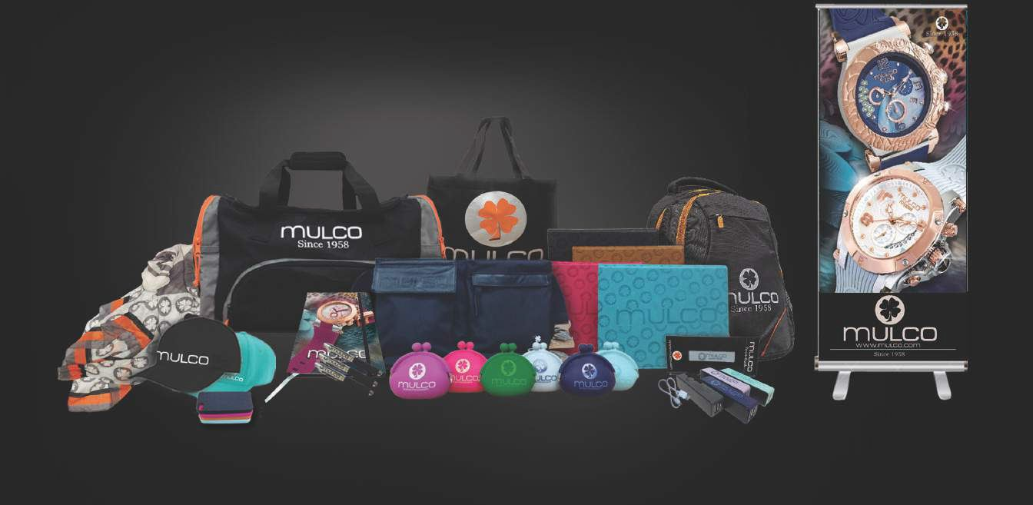
Merchandising Support (POP)

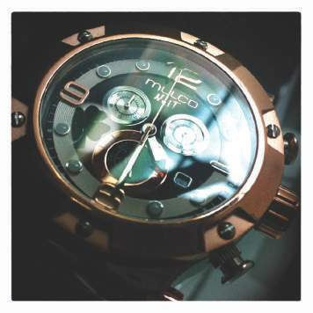

For more information please contact us at: info@mulcowatches.com or via mail:

MULCO Watches Inc. 20189 NE 16th Place Miami, Florida 33179

Tel: (305) 728-0994 Fax: (305) 816-6322 WWW.MULCO.COM

