

Facebook: Glacio Ice cream
Email:Glacio101@gmail.com
Phone:03/805220 – 70/914593
The Best way to turn something into a great success is to use your knowledge about the one thing you are passionate about.
Our traditional Ice cream redefines the combination of traditional and modern creativity

1-Ice cream
We make super-premium ice cream using the freshest fruits and the best ingredients at all which lead to a tasty , natural , rich and creamy ice cream
This is GLACIO Ice Cream !

Glacio Ice cream is a combination between traditional Arabic ice cream and its “updated version”
All our ingredients are natural and fresh so the customer can taste the difference
Some of our specialties : Nutella , Honey , Kiwi …



Samer Jbeily reviewed Glacio Ice Cream — 5 star
May 13 ·
Best ice cream in lebanon so delicious and very clean good work
TheCrêpeShopisbasedintheheartofEastLondon.Wefreshlybakedelicioussweetandsavourycrepeswithlocallysourcedingredientstomakeahottastysnackorafillingmeal.Anicechangefromthe



Mireille Karam reviewed Glacio Ice Cream — 5 star
April 23 · It was amazing and so delicious and so clean

2- “The famous crepe”
Preparing and Baking crepe is an art itself , we are “out of the box” in this field.
We deal with our crepe as a complete platter with all ingredients .
Preparing , pouring and baking is the key success for a wonderful taste.

The unique cooking process of the crêpe, made in front of the customers, can be enjoyed as an entertaining 5 step process. Watch your crêpe as it is poured, flipped and filled with our fresh ingredients straight from the market, and enjoy the fun folding and savvy serving. Filled with a variety of sweet and savory and dairy.
We guarantee freshness from start to finish. The crêpe can be eaten hot or cold any time of the day as a dine-in, take-out or on the go option.
Glacio Crepe is a place where you can enjoy freshly prepared crêpes whatever your craving, at any time of the day.
A fun and relaxed spot where great food is prepared in front of you.

3-Locations & Events

A-We were present in summer 2017 at “Deir el kalla country club “- beit Merrey
We had a big turnover due to the taste of our products and the cleanliness of our staff.
B-We were present in many festivals , recently in “Antelias festival”
C-Many restaurants are our customers for ice cream and raw material for Crepe
D-Distributing Waffle for Schools (in Progress)
4-Photos & Videos
Please refer to our facebook page to watch all videos and photos with more than 3700 likes
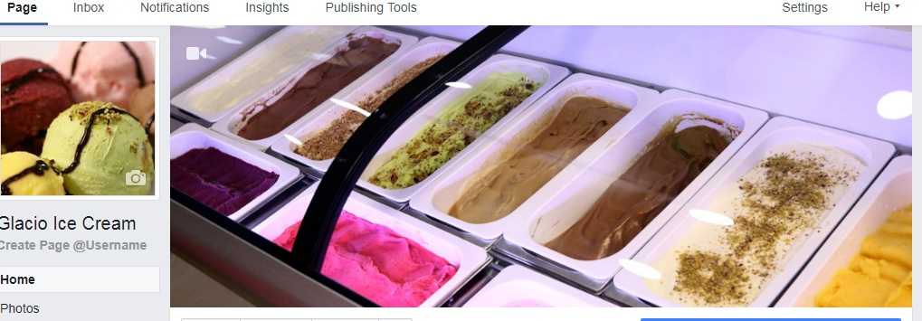
Sincerely yours

