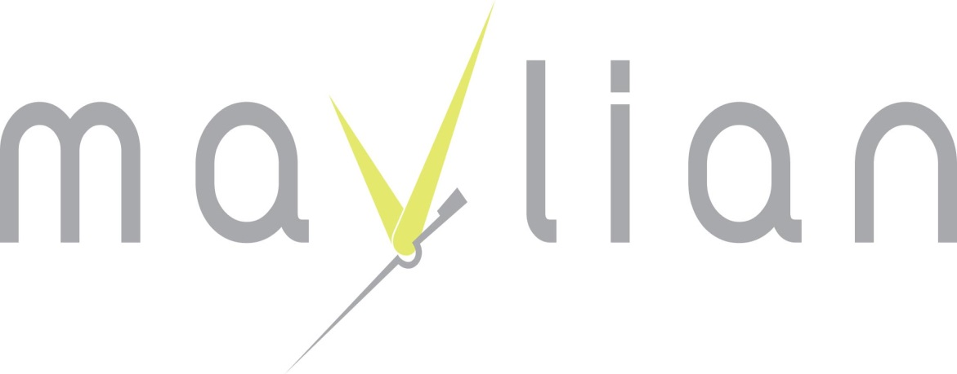
Business Information
- Business Name: CLAUDIA Watches & Jewelry
- Business Address: Bourj Hamoud, Armenia Street, John Mickel Building.
- Email: razmig.mavlian@gmail.com. razmig@claudiawatches.com
- Tel: +961-1-241249
- Fax: +961-1-241249
- Facebook: CLAUDIAWATCHES, ALEXUSCHRISTYWATCHES

Management & Activity.
Razmig Mavlian Est:
OWNER: Razmig Mavlian
We are a company have our own worldwide brand CLAUDIA watches. Producing in Hong Kong and Distributing global.
The product is FASHION WATCHES and JEWELRY designed and made by our team and always up to date according to the market in needs with a competitive price.
Our Main office in Lebanon taking care of distributing worldwide.
We are official sponsor of Miss Lebanon Emigrant Since 2010, as well as 4cats Mix dance clip.

