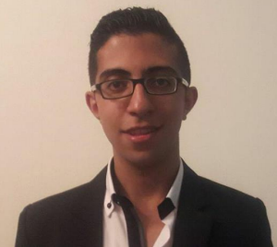

Ghassan Ismaeel Moussa
Saida, Lebanon
(+961) 70 857 217
Ghassan_Moussa@outlook.com

Date of Birth September, 4th 1997
Nationality Lebanese
Marital Status Single

Objective:
Seeking a long-term opportunity within the business community, where my experience, education, and abilities would be advantageous to the growth of my employer and myself.

Qualifications:
Excellent organizational skills, high attention to detail and ability to work under minimal supervision and pressure.

Professional Experience:
Moussa Hotline, Lebanon
Cashier (10/06/2017-Preset)

Education:
Lebanese University, Lebanon
First Year in Chemistry, 2017-2018
Baccalaureate Part Two in Life Science, 2016-2017

Computer Software:
Excel, Microsoft Word, PowerPoint, Microsoft Access and Internet Skills

Supporting Documents and References are available upon request

